Assignment 1:
Write a C program that includes a user-defined function named isPrime with the signature int isPrime(int num); The function should take an integer as a parameter and return 1 if the number is prime and 0 otherwise.
Source Code:
#include <stdio.h>
#include <math.h>

int isPrime(int);

int main()
{
int n;
printf("\n\nEnter the number: ");
scanf("%d", &n);
if (isPrime(n))
{
printf("\n\nInput %d is a Prime Number.\n", n);
}
else
{
printf("\n\nInput %d is not a Prime Number.\n", n);
}
return 0;
}

int isPrime(int n)
{
if (n <= 1)
return 0;
if (n == 2)
return 1;
if (n % 2 == 0)
return 0;
int temp = (int)sqrt(n);
int i;
for (i = 3; i <= temp; i += 2)
{
if (n % i == 0)
{
return 0;
}
}
return 1;
}
Output:
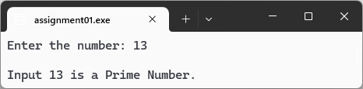
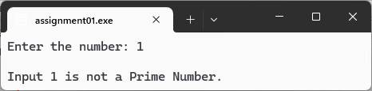
Assignment 2:
Write a C program that includes a user-defined function named isArmstrong with the signature int isArmstrong(int num); . An Armstrong number is a number that is equal to the sum of its own digits each raised to the power of the number of digits. For example, 153 is an Armstrong number because 1^3 + 5^3 + 3^3 = 153
Source Code:
#include <stdio.h>
#include <math.h>

int isArmstrong(int);
int count(int);

int main()
{
int n;
printf("Enter the number: ");
scanf("%d", &n);

if (isArmstrong(n))
{
printf("\nInput %d is a Armstrong Number.", n);
}
else
{
printf("\nInput %d is Not a Armstrong Number.", n);
}

return 0;
}

int count(int n)
{
int count = 0;
while (n > 0)
{
count++;
n = n / 10;
}
return count;
}

int isArmstrong(int n)
{
if (n < 0)
return 0;
if (n == 0)
return 1;

int power = count(n);
int temp = n;
int checker = 0;

while (temp > 0)
{
int digit = temp % 10;
checker = checker + (int)round(pow(digit, power));
temp = temp / 10;
}
return n == checker;
}

Output:
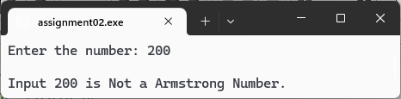
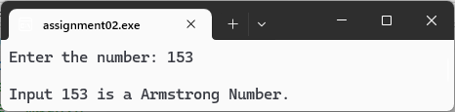
Assignment 3:
Write a C program that includes a user-defined function named isPerfect with the signature int isPerfect(int num); . A perfect number is a positive integer that is equal to the sum of its proper divisors, excluding itself. For example, 28 is a perfect number because the sum of its divisors (1, 2, 4, 7, 14) equals 28.
Source Code:
#include <stdio.h>

int isPerfect(int);

int main()
{
int n;
printf("Enter the number: ");
scanf("%d", &n);
if (isPerfect(n))
{
printf("\nInput %d is a Perfect Number.", n);
}
else
{
printf("\n\nInput %d is not a Perfect Number.", n);
}
return 0;
}

int isPerfect(int n)
{
if (n <= 1)
return 0;
int temp = 1;
int i;
for (i = 2; i <= n / 2; i++)
{
if (n % i == 0)
{
temp += i;
}
}
return temp == n;
}
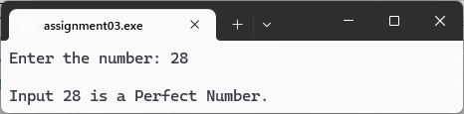
Output:

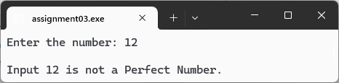

Assignment 4:
Write a C program that takes an integer input representing a month (1 to 12) and a year. Use a switch statement to display the number of days in that month, considering leap years.
Source Code:
#include <stdio.h>
int main()
{
int month, year, days;
printf("Enter the month (1 to 12) and year: ");
scanf("%d %d", &month, &year);
switch (month)
{
case 1: // jan
case 3: // mar
case 5: // may
case 7: // jul
case 8: // aug
case 10: // oct
case 12: // dec
days = 31;
break;
case 4: // apr
case 6: // jun
case 9: // sep
case 11: // nov
days = 30;
break;
case 2: // feb
if ((year % 400 == 0) || ((year % 4 == 0) && (year % 100 != 0)))
{
days = 29;
}
else
{
days = 28;
}
break;
default:
printf("\nYou entered something wrong.");
return 1;
}
printf("\nNumber of days: %d", days);
return 0;
}
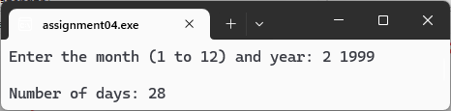
Output:
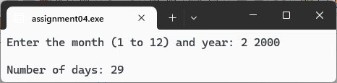

Assignment 5:
Write a C program that defines an array of integers, and includes a user-defined function named reverseArray with the signature void reverseArray(int arr[], int size);. The function should reverse the elements of the array.
Source Code:
#include <stdio.h>

void inputArray(int[], int);
void reverseArray(int[], int);

int main()
{
int size;
printf("How many element do you want to add: ");
scanf("%d", &size);
int arr[size];
inputArray(arr, size);
reverseArray(arr, size);
return 0;
}

void inputArray(int arr[], int size)
{
int i;
for (i = 0; i < size; i++)
{
printf("Enter element %d: ", i + 1);
scanf("%d", &arr[i]);
}
}

void reverseArray(int arr[], int size)
{
int i, j, temp;
printf("\nBefore Reverse: \n");
for (i = 0; i < size; i++)
{
printf("Position: %d, Value: %d\n", i, arr[i]);
}

for (i = 0, j = size - 1; i < j; i++, j--)
{
temp = arr[i];
arr[i] = arr[j];
arr[j] = temp;
}

printf("\nAfter Reverse: \n");
for (i = 0; i < size; i++)
{
printf("Position: %d, Value: %d\n", i, arr[i]);
}
}
Output:
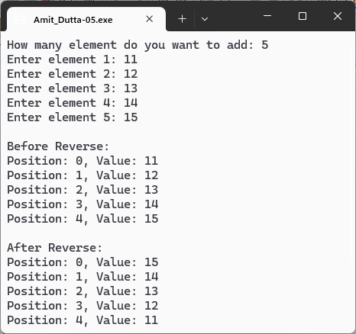

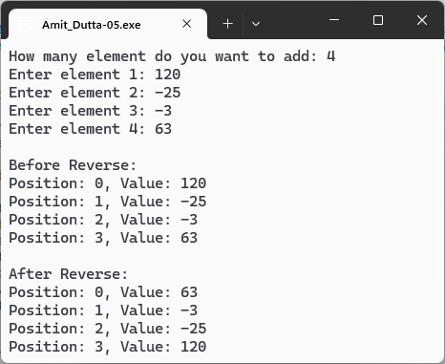
Assignment 6:
Write a C program that includes a user-defined function named findLargest with the signature
int findLargest(int arr[], int size);. The function should take an array of integers and its size, and return the largest element in the array.
Source Code:
#include <stdio.h>

void inputArray(int[], int);
int findLargest(int[], int);

int main()
{
int size;
printf("How many element do you want to enter: ");
scanf("%d", &size);
int arr[size];
inputArray(arr, size);
printf("\nLargest Element is: %d", findLargest(arr, size));
return 0;
}

void inputArray(int arr[], int size)
{
int i;
for (i = 0; i < size; i++)
{
printf("Enter element %d: ", i + 1);
scanf("%d", &arr[i]);
}
}

int findLargest(int arr[], int size)
{
int largest = arr[0], i;
for (i = 1; i < size; i++)
{
if (largest < arr[i])
{
largest = arr[i];
}
}
return largest;
}
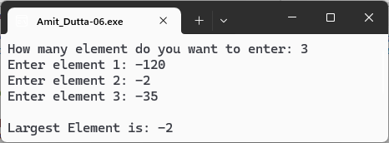
Ouptut:

Output:
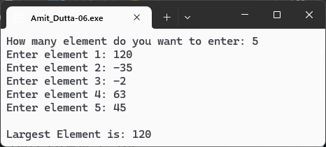

Assignment 7:
Write a C program that includes a user-defined function named binarySearch with the signature
int binarySearch(int arr[], int size, int target);. The function should perform a binary search on a sorted array of integers and return the index of the target element if found, and -1 otherwise.
Source Code:
#include <stdio.h>

int inputArray(int[], int);
int binarySearch(int[], int, int);

int main()
{
int size;
printf("How many element do you want to enter: ");
scanf("%d", &size);
int arr[size];
int target = inputArray(arr, size);
int index = binarySearch(arr, size, target);
if (index != -1)
{
printf("\nElement %d is found at index %d.", target, index);
}
else
{
printf("\nElement %d is not found.", target);
}
return 0;
}

int inputArray(int arr[], int size)
{
int i, target;
for (i = 0; i < size; i++)
{
printf("Enter element for position %d: ", i);
scanf("%d", &arr[i]);
}
printf("\nEnter the target element: ");
scanf("%d", &target);
return target;
}

int binarySearch(int arr[], int size, int target)
{
int low = 0;
int high = size - 1;
int mid;
while (low <= high)
{
mid = low + ((high - low) / 2);
if (arr[mid] == target)
{
return mid;
}
else if (arr[mid] > target)
{
high = mid - 1;
}
else if (arr[mid] < target)
{
low = mid + 1;
}
}
return -1;
}
Output:
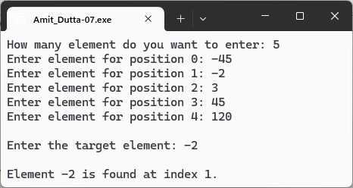
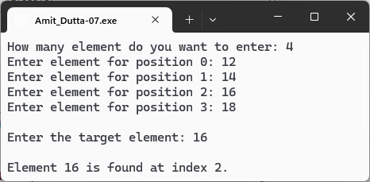

Assignment 8:
Write a C program that includes a user-defined function named countSetBits with the
signature int countSetBits(int num);. The function should count and return the number of
set bits (1s) in the binary representation of the given number.
Source Code:
#include <stdio.h>
int countSetBits(int);
int main()
{
int num, result;
printf("Enter the number: ");
scanf("%d", &num);
if (result = countSetBits(num))
{
printf("\nNumber of set bits in %d: %d", num, result);
}
else
{
printf("\nThere is no set bits in %d", num);
}
return 0;
}
int countSetBits(int num)
{
int count = 0;
int mask= 1;
int i = 1;
while (i <= 16)
{
if (num & mask)
{
count++;
}
mask <<= 1;
i++;
}
return count;
}
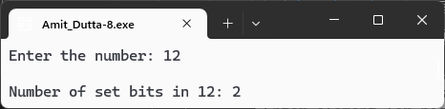
Output:

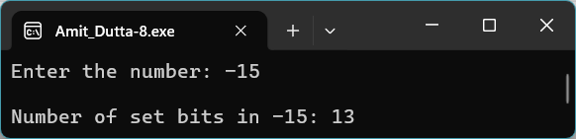

Assignment 9:
Write a C program that includes a user-defined function named setBit with the signature
int setBit(int num, int position);. The function should set the bit at the specified position
(0-indexed) to 1 and return the modified number.
Source Code:
#include <stdio.h>

int setBit(int, int);

int main()
{
int num, position;
printf("Enter the number: ");
scanf("%d", &num);
printf("Enter the postion where you want to set the bit (0-indexed): ");
scanf("%d", &position);
printf("\nModified number = %d", setBit(num, position));
return 0;
}

int setBit(int num, int position)
{
int mask = 1 << position;
return num | mask;
}
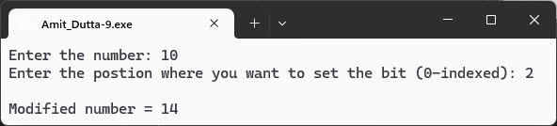
Output:

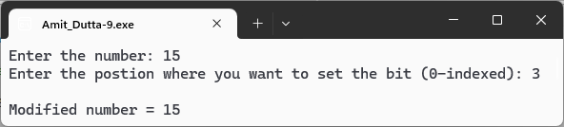

Assignment 10:
Write a C program that defines a structure Rectangle with attributes length and width. Include a user-defined function named calculateArea with the signature float calculateArea(struct Rectangle r);. The function should calculate and return the area of the rectangle.
Source Code:
#include <stdio.h>

struct Rectangle
{
float length;
float width;
};

float calculateArea(struct Rectangle);

int main()
{
struct Rectangle rectangle;
printf("Enter the length of the Rectangle: ");
scanf("%f", &rectangle.length);
printf("Enter the width of the Rectangle: ");
scanf("%f", &rectangle.width);
printf("\nArea of the Rectangle = %g", calculateArea(rectangle));
}

float calculateArea(struct Rectangle r)
{
return r.length * r.width;
}

Output:
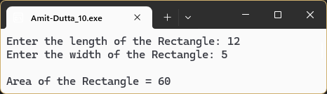

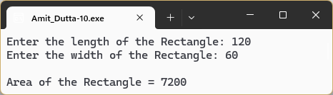

Assignment 11:
Write a C program that defines a structure Student containing the attributes rollNumber, name, and marks. Include a user-defined function named displayStudent with the signature void displayStudent(struct Student s);. The function should display the details of a student.
Source Code:
#include <stdio.h>
#include <string.h>
#include <stdlib.h>
struct Student
{
int rollNumber;
char name[50];
float marks;
};
void inputStudent(struct Student *);
void displayStudent(struct Student);
int main()
{
struct Student *std = NULL;
int i, n;

printf("How many student details you want to add : ");
if (scanf("%d", &n) != 1 || n < 1)
{
printf("\nInvalid Input.");
return 1;
}

std = (struct Student *)malloc(n * sizeof(struct Student));
if (std == NULL)
{
printf("\nUnable to allocate memory.");
return 1;
}

for (i = 0; i < n; i++)
{
printf("\n- Enter details of Student %d -", i + 1);
inputStudent(&std[i]);
}

printf("\n=== Student Details ===\n");
for (i = 0; i < n; i++)
{
displayStudent(std[i]);
}
free(std);
return 0;
}
void inputStudent(struct Student *std)
{
int len;

printf("\nEnter the Roll Number: ");
scanf("%d", &std->rollNumber);
getchar();

printf("Enter the Name (Max: 50 character): ");
fgets(std->name, sizeof(std->name), stdin);
len = strlen(std->name);
if (len > 0 && std->name[len - 1] == '\n')
{
std->name[len - 1] = '\0';
}

printf("Enter the Marks: ");
scanf("%f", &std->marks);
}
void displayStudent(struct Student std)
{
printf("\n%-12s : %d", "Roll Number", std.rollNumber);
printf("\n%-12s : %s", "Name", std.name);
printf("\n%-12s : %g\n", "Marks", std.marks);
}
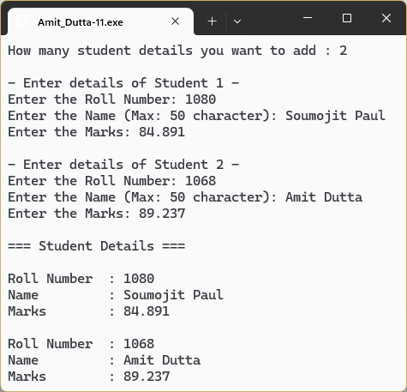
Output:

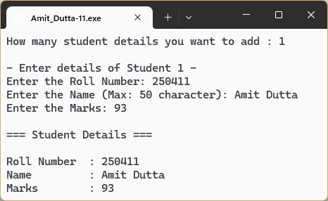

Assignment 12:
Write a C program that takes multiple integers as command-line arguments and finds the
maximum and minimum value among them.
Source Code:
#include <stdio.h>
#include <stdlib.h>

int main(int argc, char *argv[])
{
int current_val, max_val, min_val, i;
if (argc < 2)
{
printf("Usage: %s <integer1> <integer2> ...\n", argv[0]);
return 1;
}
max_val = atoi(argv[1]);
min_val = atoi(argv[1]);
for (i = 2; i < argc; i++)
{
current_val = atoi(argv[i]);

if (current_val > max_val)
{
max_val = current_val;
}
if (current_val < min_val)
{
min_val = current_val;
}
}
printf("The maximum value is: %d\n", max_val);
printf("The minimum value is: %d\n", min_val);
return 0;
}
Output:
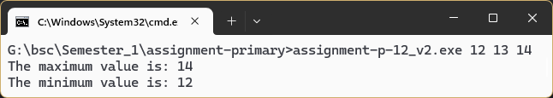
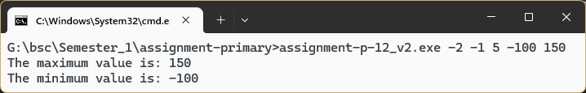

Assignment 13:
Write a C program that accepts a string as a command line argument and includes a user-
defined function named isPalindrome with the signature int isPalindrome(char str[]);.
The function should check if the given string is a palindrome and return 1 if it is, and 0
otherwise.
Source code:
#include <stdio.h>
#include <stdlib.h>
#include <string.h>

int isPalindrome(char[]);

int main(int argc, char *argv[])
{
if (argc != 2)
{
printf("\nUsage: %s <string>\n", argv[0]);
return 1;
}

if (isPalindrome(argv[1]))
{
printf("\nThe entered string \"%s\" is Palindrome.\n", argv[1]);
}

else
{
printf("\nThe entered string \"%s\" is not Palindrome.\n", argv[1]);
}

return 0;
}

int isPalindrome(char str[])
{
char *start = str;
char *end;
int len = strlen(str);

if (len == 0)
{
return 1;
}
end = str + (len - 1);

while (start < end)
{
if (*start != *end)
{
return 0;
}
start++;
end--;
}
return 1;
}
Output:
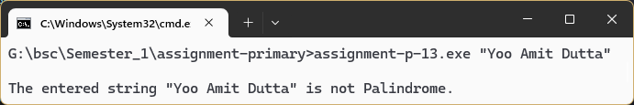
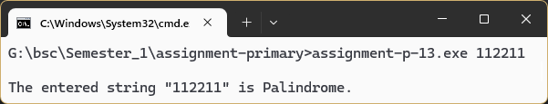

Assignment 14:
Write a C program that opens its own source code file, reads its contents, and then prints the contents to the console.
Source Code:
#include <stdio.h>
#define FILENAME "assignment-p-14_v2.c"
int main()
{
FILE *code = NULL;
char temp;
code = fopen(FILENAME, "r");
if (code == NULL) {
printf("\nCould not open the source file: %s", FILENAME);
return 1;
}
printf("Reading file: %s", FILENAME);
printf("\n========== %s ==========\n\n", FILENAME);
while ((temp = fgetc(code)) != EOF) {
printf("%c", temp);
}
printf("\n========== End of %s ==========\n", FILENAME);
fclose(code);
return 0;
}
Output:
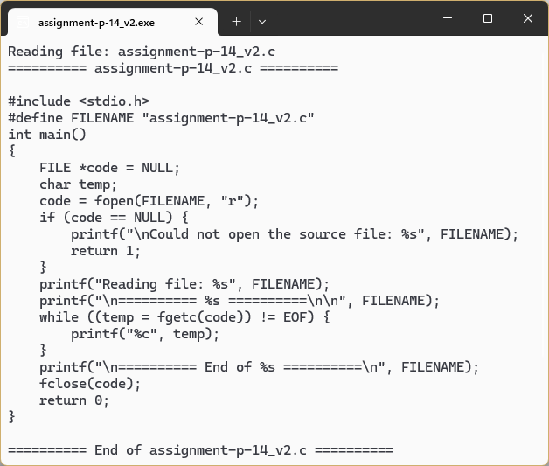
Assignment 15:
Write a C program that reads a sequence of integers from a file named 'input.txt'. This
program should segregate the odd numbers from the even numbers and store the odd
numbers in a new file named 'ODDFile.txt' while storing the even numbers in another file
named 'EVENFile.txt'.
Source Code:
#include <stdio.h>

#define FILENAME "input.txt"
#define ODDFILE "ODDFile.txt"
#define EVENFILE "EVENFile.txt"

int main()
{
FILE *input = NULL;
FILE *oddfile = NULL;
FILE *evenfile = NULL;

int num;

input = fopen(FILENAME, "r");
if (input == NULL)
{
printf("\nCould not open the file: %s", FILENAME);
return 1;
}

oddfile = fopen(ODDFILE, "w");
if (oddfile == NULL)
{
printf("\nCould not open the file: %s", ODDFILE);
return 1;
}

evenfile = fopen(EVENFILE, "w");
if (evenfile == NULL)
{
printf("\nCould not open the file: %s", EVENFILE);
return 1;
}

while (fscanf(input, "%d", &num) == 1)
{
if (num % 2 == 0)
{
fprintf(evenfile, "%d ", num);
}
else
{
fprintf(oddfile, "%d ", num);
}
}

printf("Successfully processed numbers from %s.\n", FILENAME);
printf("Odd numbers written to %s.\n", ODDFILE);
printf("Even numbers written to %s.\n", EVENFILE);

fclose(input);
fclose(oddfile);
fclose(evenfile);

return 0;
}
Output:
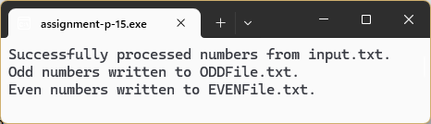
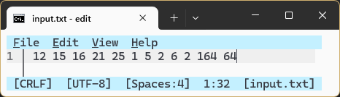
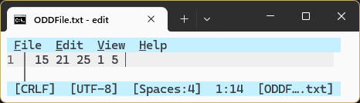
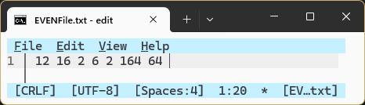

Assignment 15:
Write a C program that reads a sequence of integers from a file named 'input.txt'. This
program should segregate the odd numbers from the even numbers and store the odd
numbers in a new file named 'ODDFile.txt' while storing the even numbers in another file
named 'EVENFile.txt'.
Source Code:
#include <stdio.h>

#define FILENAME "input.txt"
#define ODDFILE "ODDFile.txt"
#define EVENFILE "EVENFile.txt"

int main()
{
FILE *input = NULL;
FILE *oddfile = NULL;
FILE *evenfile = NULL;

int num;

input = fopen(FILENAME, "r");
if (input == NULL)
{
printf("\nCould not open the file: %s", FILENAME);
return 1;
}

oddfile = fopen(ODDFILE, "w");
if (oddfile == NULL)
{
printf("\nCould not open the file: %s", ODDFILE);
return 1;
}

evenfile = fopen(EVENFILE, "w");
if (evenfile == NULL)
{
printf("\nCould not open the file: %s", EVENFILE);
return 1;
}

while (fscanf(input, "%d", &num) == 1)
{
if (num % 2 == 0)
{
fprintf(evenfile, "%d ", num);
}
else
{
fprintf(oddfile, "%d ", num);
}
}

printf("Successfully processed numbers from %s.\n", FILENAME);
printf("Odd numbers written to %s.\n", ODDFILE);
printf("Even numbers written to %s.\n", EVENFILE);

fclose(input);
fclose(oddfile);
fclose(evenfile);

return 0;
}
Output:
